1. Show the sequence of numbers that would be generated by each of the following range expressions.

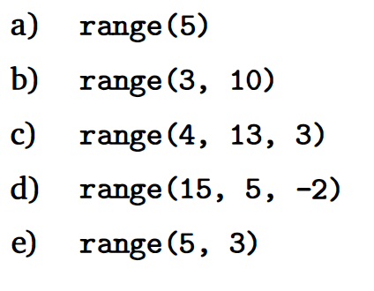

a)

0

1

2

3

4

b)

3

4

5

6

7

8

9

c)

4

7

10

d)

15

13

11

9

7

e)

no output

1. Show the output that would be generated by each of the following program fragments.

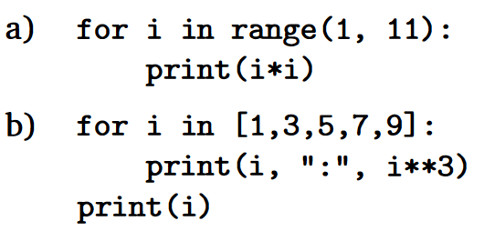

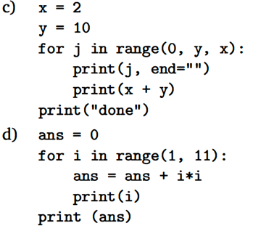

a)

1

4

9

16

25

36

49

64

81

100

b)

1 : 1

3 : 27

5 : 125

7 : 343

9 : 729

9

c)

012

212

412

612

812

done

d)

1

2

3

4

5

6

7

8

9

10

385

1. Write a program to calculate the volume and surface area of a sphere from its radius, given as input. Here are some formulas that might be useful:

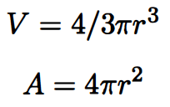

Hint: Use the math library. The math.pow(x,y) function returns the value of x raised to the y power. For example, math.pow(2,3) returns 8.0.

import math

def main():

r = eval(input("Please enter the radius of a sphere: "))

v = (4/3) \* math.pi \* math.pow(r, 3)

a = 4 \* math.pi \* math.pow(r, 2)

print("You entered a radius of",r)

print("The volume of the sphere is",v)

print("The area of the sphere is",a)

main()